Ross, William A (Bill)
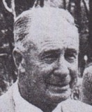
One of the original students at the Ludlow Apprentice School. Started as forest apprentice in March 1917, with the W.A. Forests Dept. Worked for Forests Department 1920s-1960s. Retired in 1962/63.

